**COLLEGE ENTERPRISE RESOURCE PLANNING**

***A thesis***

***submitted in partial fulfillment of the***

***requirements for the award of the Degree of***

**BACHELOR OF ENGINEERING**

**IN**

**COMPUTER SCIENCE & ENGINEERING**

BY

**AVEG CHAUDHARY (BE/25108/11)**

**AAYUSHI SHARMA (BE/25099/11)**

**RUCHIKA SINGH (BE/25152/11)**

**KHARANSHU SAINI (BE/25098/11)**



**DEPARTMENT OF COMPUTER SCIENCE & ENGINEERING**

**BIRLA INSTITUTE OF TECHNOLOGY, MESRA**

**JAIPUR CAMPUS**

**2014-15**

**DECLARATION CERTIFICATE**

This is to certify that the project entitled ”**College Enterprise Resource Planning for Academics”** in partial fulfillment of the requirements for the award of Degree of **Bachelor of Engineering in Computer science & Engineering** of the Birla Institute of Technology Mesra, Ranchi is an authentic work carried out by them under my supervision and guidance.

To the best of my knowledge, the content of this thesis does not

form a basis for the award of any previous Degree to anyone else.

Date: Mrs. Seema Gaur

(Assistant Professor)

Dept. of Computer Science & Engineering

Birla Institute of Technology

Jaipur Centre, Mesra

In-charge

Dept. of Computer Science & Engineering

Birla Institute of Technology

Jaipur Center, Mesra

**CERTIFICATE OF APPROVAL**

The foregoing thesis entitled “**College Enterprise Resource Planning For Academics”,** is hereby approved as a creditable study of research topic and has been presented in satisfactory manner to warrant its acceptance as prerequisite to the degree for which it has been submitted.

It is understood that by this approval, the undersigned do not necessarily endorse any conclusion drawn or opinion expressed Therein, but approve the thesis for the purpose for which it is submitted.

(Internal Examiner) (External Examiner)

(Head of the Department)

**ACKNOWLEDGEMENT**

We would like to gratefully acknowledge the kind guidance and expert supervision of **Mrs. Seema Gaur** throughout this work. Her consistent support has always been an immense source of motivation and encouragement.

We sincerely express our gratefulness to **Dr. Madhavi Sinha**, Head of Department, Computer Science & Engineering for allotting us this project and also for resource that were made available to us whenever we needed them.

Lastly, we would likely to thank all the people who have contributed to the successful completion of the project.

Aveg Chaudhary

Aayushi Sharma

Ruchika Singh

Kharanshu Saini

**ABSTRACT**

Enterprise Resource Planning (ERP) System is a software that allows an organization to use a system of integrated applications to manage the available resources of the enterprise. The college ERP system is basically used to manage the resources of a college to the fullest by the use of various integrated applications.

Previously, all the resource management activities were performed manually which utilize a lot of man hours and paper work. The system which we have proposed reduces the man hours and also follows the eco-friendly concept.

ERP software consists of many enterprise software modules that an enterprise would purchase, based on what best meets its specific needs and technical capabilities. Each ERP module is focused on one area of business processes, such as product development or marketing. Apart from managing the administrative, financial and academic functions of the institution, College ERP provides a platform for sharing information between all the stakeholders, viz. Students, Teachers, Administrators and Management.

**TABLE OF CONTENTS**

DECLARATION CERTIFICATE…………………………………………………….3

CERTIFICATE OF APPROVAL……………………………………………………..4

ACKNOWLEDGEMENT……………………………………………………………..5

ABSTRACT…………………………………………………………………………...6

INTRODUCTION……………………………………………………………………..8

1.1 Benefits for College…………………………………………………………………..9

1.2 Benefits for Students………………………………………………………………….9

1.3 Benefits for Administration….……………………………………………………….9

SRS 10

SDS………………………………………………………………………………......24.

IMPLEMENTATION………………………………………………………………..38

2.1 Attendance module 38

2.2 Feedback module 45

2.3 Result module 47

TESTING 48

3.1 Types of testing 48

3.2 Unit testing 50

3.3 Integration testing 52

3.4 Acceptance testing 54

FUTURE SCOPE 56

REFERENCES……………………………………………………………………….57

1. **Introduction**

The Enterprise Resource Planning System (ERP) is business management software that allows an organization to use a system of integrated applications to manage the business. The college ERP system is basically used to manage the resources of a college to the fullest by the use of various integrated applications.

The software is aimed at bringing in process refinement, efficiency, accountability and control in a College. College ERP is built using the DotNet Technology. The software uses SqlServer 2008 as the Database and runs on the Local server. The service is adequately protected by Firewalls, Intrusion Detectors and Antivirus software.

Apart from managing the administrative, financial and academic functions of the institution, College ERP provides a platform for sharing information between all the stakeholders, viz. Students, Teachers, Administrators and Management, thus ensuring:

* Transparency in administration at all levels.
* Accountability in the system.
* Improvement in the quality of education management.
* Reducing paper work and promoting green force.
* Utilization of college resources effectively and efficiently.

The college ERP system is integrated with these modules

* Attendance Management System
* Feedback System
* Results

1) Attendance Management System

Attendance Management System is used to store the student’s attendance on the daily basis, and generate the report. Teachers have a unique login id and password, by which they can login into the system and upload the attendance. In this module users has their different role. The functions of user’s are defined according to their role. The authorities of the institution can check the attendance any time and can update the attendance. The faculty cannot update the attendance they can only upload the attendance.

2) Feedback System

The Feedback system is used to take the feedback of students regarding the teaching methodology. Feedback system maintains a record of this feedback and the report is generated in the many formats, like Class wise, student wise, faculty wise, faculty’s total feedback in all subjects, and faculty’s individual subjects. The feedback is calculated automatically according to the requirement. A unique id is given to the every student, a comment option is also given on the feedback form in which students can give their suggestions.

3) Results

This module is used to store the student’s marks of the mid-semester and end-semester, and generate the report on the basis of these marks. Teachers have a unique login id and password, by which they can login into the system and upload the marks of the students. In this module users has their different role. The functions of user’s are defined according to their role. The authorities of the institution can check the marks any time and can update the same. The faculty cannot update the marks once uploaded into the system.

### 1.1 Benefits for College

* Management information system.
* Decision support system.
* Common platform for Student, Parents, Teachers and Management.
* Transparency in the system for Students, Teachers and Management.
* Simple and easy to implement and maintenance free environment.

### 1.2 Benefits for Students

* Easy exposure to student attendance.
* Anonymous feedback can be given to the respective faculties.
* Can easily view their marks.
* Academic as well as Non Academic info.

### 1.3 Benefits for Management

* Availability of real-time information.
* Easy Command, Control and communication.
* Paper less transactions.
* Ability to save time and money.
* Monitoring the student progress.
* Easy maintenance of student marks and attendance.

**SOFTWARE REQUIREMENTS SPECIFICATION (SRS)**

## 1. Introduction

## 1.1 Purpose

The purpose of this document is to provide a consistent and complete description of the requirements for the software of an Enterprise Resource Planning (ERP). The requirements will be presented using textual description to explain concepts, different types of diagrams to illustrate complicated interaction, and tables to relate relevant information.

The intended audience of this document included all stakeholders in the potential system. This includes the project mentor and the design team.

## 1.2 Scope

Enterprise Resource Planning (ERP) System is software that allows an organization to use a system of integrated applications to manage the available resources of the enterprise. The college ERP system is basically used to manage the resources of a college to the fullest by the use of various integrated applications.

Previously, all the resource management activities were performed manually which utilize a lot of man hours and paper work. The system which we have proposed reduces the man hours and also follows the eco-friendly concept.

ERP software consists of many enterprise software modules that an enterprise would purchase, based on what best meets its specific needs and technical capabilities. Each ERP module is focused on one area of business processes, such as product development or marketing. Apart from managing the administrative, financial and academic functions of the institution, College ERP provides a platform for sharing information between all the stakeholders, viz. Students, Teachers, Administrators and Management. The Entity Resource Planning System (ERP) is business management software that allows an organization to use a system of integrated applications to manage the business. The college ERP system is basically used to manage the resources of a college to the fullest by the use of various integrated applications.

The software is aimed at bringing in process refinement, efficiency, accountability and control in a College. Apart from managing the administrative, financial and academic functions of the institution, College ERP provides a platform for sharing information between all the stakeholders, viz. Students, Teachers, Administrators and Management, thus ensuring:

* Transparency in administration at all levels.
* Accountability in the system.
* Improvement in the quality of education management.
* Reducing paper work and promoting green force.
* Utilization of college resources effectively and efficiently.

## 1.3 Definitions, Acronyms, and Abbreviations

**ERP:** Enterprise Resource Planning System

**FS:** Feedback System

**AMS:** Attendance Management System

**1.4 References**

* Mary Sumner, “Enterprise Resource Planning”.
* Ejaz Ahmed Bhatti, “ERP a Research Study Paper”.
* http://www.smashingmagazine.com/2008/01/17/adobe-flash-tutorials-best-of/
* http://www.tizag.com/phpT/phpfunctions.php
* http://www.learn-javascript-tutorial.com/FormValidation.cfm#h1.1

## 1.5 Overview

This document completely describes the following:

* Scope of the project
* Product Features
* User Classes and Characteristics
* Use cases and DFDs
* Design and implementation constraints

## 2. General Description

## 2.1 Product Perspective

## The Entity Resource Planning System (ERP) is business management software that allows an organization to use a system of integrated applications to manage the business. The college ERP system is basically used to manage the resources of a college to the fullest by the use of various integrated applications.

## 2.2 Product Functions

The college ERP system is integrated with these modules

* Feedback System
* Attendance Management System
* Result Module

1) Feedback System

The Feedback system is used to take the feedback of students regarding the teaching methodology. Feedback system maintains a record of this feedback and the report is generated in the many formats, like Class wise, student wise, faculty wise, faculty’s total feedback in all subjects, and faculty’s individual subjects. The feedback is calculated automatically according to the requirement. A unique id is given to the every student, a comment option is also given on the feedback form in which students can give their suggestions.

2) Attendance Management System

Attendance Management System is used to store the student’s attendance on the daily basis, and generate the report. Teachers have a unique login id and password, by which they can login into the system and upload the attendance. In this module users has their different role. The functions of user’s are defined according to their role. The authorities of the institution can check the attendance any time and can update the attendance. The faculty cannot update the attendance they can only upload the attendance.

3) Result Module

This system is used to store the student’s marks of the end semester and mid semester, and generate the report on the basis of this and Class wise. Teachers have a unique login id and password, by which they can login into the system and upload the marks of the students. In this module users has their different role. The functions of user’s are defined according to their role. The authorities of the institution can check the marks any time and can update the same. The faculty cannot update the marks once uploaded into the system.

**2.3 User Characteristics**

* **Teachers** Transparency in the system for Students and Teachers.
* **Students** Easy exposure to academic as well as Non Academic info.
* **Management** Easy Command, Control and communication.

**2.4 General Constraints**

**ERP** will require some amount of manual administration as the product is not completely automated. It has to be updated at regular intervals as per requirements.

## 2.5 Assumptions and Dependencies

* The project is based on the following assumptions:
* Some modules require regular update by the respective user.
* Optional components of the project would only be implemented only if the time and required resources are available.
* As now the project scope/core functionalities to achieve have been finalized, scope may not be further enhanced at any stage during the project construction. But changes in process as per requirement and optimization may be incorporated.

## 3. Specific Requirements

## 3.1 External Interface Requirements

## 3.1.1 User Interfaces

* The Interface will be graphical.
* The Project will be web based.
* The Interface will be user friendly.
* All the Statements will be stored in separate files.

All of the above components will be present on the home screen and the user will be required to select a particular component based on his/her needs. The selected component will then provide the interface to carry out the remaining task.

While navigating through the mentioned functionalities if a user goes against the intended behaviour which is required from the user, application would generate an error message informing the user about the cause of the error.

## 3.1.2 Hardware Interfaces

* A keyboard to enter the data.
* A monitor to display the data.
* Pentium-IV processor or higher.
* 256 MB RAM or higher.
* A printer to take hard copies of required data.
* 1 GB free space on Hard Disk.
* A server to run the ERP System.(Windows 2003 or higher)

## 3.1.3 Software Interfaces

As the application will be built on Windows operating system, so it will definitely use the routines and procedures of the underlying OS. As the implementation of the system will be supported from certain libraries, for certain tasks to be done, the application will certainly interact with those libraries.

MYSQL Server 2005 and a Web Browser

## 3.1.4 Communications Interfaces

All components of **ERP** will require an internet connection.

## 3.2 Functional Requirements

**3.2.1 Introduction**

* The System features have been divided into the following *three categories:*
* Store the user selected data
* Match the text from the database
* Display appropriate content

## 3.2.2 Inputs

The foremost step in the development of the system is taking input from user. User will select several inputs using checkboxes.

## 3.2.3 Processing

After getting the input, the system will match the entries with the stored data and select the most appropriate entries.

## 3.2.4 Outputs

1. ERP will provide output according to the component selected.
2. It will also display the results and attendance of students.

## 3.2.5 Error Handling

In case of absurd inputs or any fault within the system, instead of providing garbage or inappropriate outputs, the system will display Errors, may be specific or general. The system can be restarted again in such case.

## 3.3 ER Diagram

Main Interface

Attendance

Marks Management

Feedback

Menu

Menu

Menu

View

Login

Login

Login

User

User

User

Update

View

Upload

Update

Report

Faculty

HOD/DEAN/ED

Director

Admin

Students

HOD/DEAN/ED

Faculty

Update

Director

Upload

Students

Performance Report

## 3.4 Non-Functional Requirements

## 3.4.1 Performance

For the best performance of the software user must not run any other application in the background.

## 3.4.2 Reliability

The system will be designed to provide maximum authenticity.

## 3.4.3 Availability

The application will be available 24/7, provided server is in working state and application is configured properly.

## 3.4.4 Security

The database will be designed to be highly secure. Only the admin will be allowed to access and update the database as per the requirements.

## 3.4.5 Maintainability

The application can be easily restored in case of a system crash.

1. **System Design**

**4.1.** **High Level Design Diagram (Modules Identification)**

HOD

Login Details

Login API

End Semester Performance Report

View Reports

View Performance Report

View Reports

View Reports

Update Records

FACULTY

STUDENT

ED/DEAN

DIRECTOR

View Reports

Enter Sessional Marks

## 

**Level 1: Result Module**

HOD

Login Details

Login API

End Semester Performance Report

View Reports

View Performance Report

View Reports

View Reports

Update Records

FACULTY

STUDENT

ED/DEAN

DIRECTOR

View Reports

Enter Attendance

**Level 1: Attendance Management System**

ADMIN

Login Details

Login API

End Semester Performance Report

Give Faculties feedback

View Reports

View Reports

STUDENT

ED/DEAN

DIRECTOR

View Reports

ADMIN

Login Details

Login API

End Semester Performance Report

Give Faculties feedback

View Reports

View Reports

STUDENT

ED/DEAN

DIRECTOR

View Reports

**Level 1: Feedback System**

## 4.2 Software Components

## Our project contains following software components:

* **Operating Systems:** Windows 7
* **Software Packages**
* Visual Studio 2010
* SQL server 2008 R2

## 

## 4.3 Hardware Components

Our project contains following hardware components: Personal Computer(s)

## 4.4 Data Flow Diagram:

**Feedback**

**Attendance**

**Sessional**

**Report Generation**

# 

**SDS(Software Design Specification)**

**1. Introduction**

* 1. **Purpose**

The purpose of this document is to provide a consistent and complete description of the requirements for the software of an Enterprise Resource Planning (ERP). The requirements will be presented using textual description to explain concepts, different types of diagrams to illustrate complicated interaction, and tables to relate relevant information.

The intended audience of this document included all stakeholders in the potential system. This includes the project mentor and the design team.

**1.2 Scope of the development project**

Enterprise Resource Planning (ERP) System is software that allows an organization to use a system of integrated applications to manage the available resources of the enterprise. The college ERP system is basically used to manage the resources of a college to the fullest by the use of various integrated applications.

Previously, all the resource management activities were performed manually which utilize a lot of man hours and paper work. The system which we have proposed reduces the man hours and also follows the eco-friendly concept.

ERP software consists of many enterprise software modules that an enterprise would purchase, based on what best meets its specific needs and technical capabilities. Each ERP module is focused on one area of business processes, such as product development or marketing. Apart from managing the administrative, financial and academic functions of the institution, College ERP provides a platform for sharing information between all the stakeholders, viz. Students, Teachers, Administrators and Management. The Entity Resource Planning System (ERP) is business management software that allows an organization to use a system of integrated applications to manage the business. The college ERP system is basically used to manage the resources of a college to the fullest by the use of various integrated applications.

The software is aimed at bringing in process refinement, efficiency, accountability and control in a College. Apart from managing the administrative, financial and academic functions of the institution, College ERP provides a platform for sharing information between all the stakeholders, viz. Students, Teachers, Administrators and Management, thus ensuring:

* Transparency in administration at all levels.
* Accountability in the system.
* Improvement in the quality of education management.
* Reducing paper work and promoting green force.
* Utilization of college resources effectively and efficiently.

The college ERP system is integrated with these modules

* Feedback System
* Attendance Management System
* Results

**1.3 Definitions, acronyms, and abbreviations**

**ERP:** Enterprise Resource Planning System

**FS:** Feedback System

**AMS:** Attendance Management System

**1.4 References**

* Seyed Tahaghoghi and Hugh Williams, “Learning MySQL”.
* John Pollock, “JavaScript: A Beginner’s Guide”.
* Ellen Monk and Bret Wagner,“Concepts in Enterprise Resource Planning”.
* Mary Sumner, “Enterprise Resource Planning”.
* Ejaz Ahmed Bhatti, “ERP a Research Study Paper”.

**1.5 Overview of document**

This document completely describes the following:

* Scope of the project
* Product Features
* User Classes and Characteristics
* Use cases and DFDs
* Design and implementation constraints

**2.1 System architecture description**

College ERP is built using the latest .Net Technology. The software uses MYSQL as the Database and runs MS Visual Studio Server. The service is adequately protected by Firewalls, Intrusion Detectors and Antivirus software.

## 2.1.1 Feedback System

The Feedback system is used to take the feedback of students regarding the teaching methodology. Feedback system maintains a record of this feedback and the report is generated in the many formats, like Class wise, student wise, faculty wise, faculty’s total feedback in all subjects, and faculty’s individual subjects. The feedback is calculated automatically according to the requirement. A unique id is given to the every student, and this id is generating randomly, a comment option is also given on the feedback form in which students can give their suggestions. The student wise feedback is generated according to their unique feedback id.

## 2.1.2 Attendance Management System

Attendance Management System is used to store the student’s attendance on the daily basis, and generate the report on the basis of the L, T, P. Teachers have a unique login id and password, by which they can login into the system and upload the attendance. In this module users has their different role. The functions of user’s are defined according to their role. The authorities of the institution can check the attendance any time and can update the attendance. The faculty cannot update the attendance they can only upload the attendance.

## 2.1.3 Result module

Marks Management System is used to store the student’s marks of the mid semester and end semester, and generate the report on the basis of these marks and Class wise. Teachers have a unique login id and password, by which they can login into the system and upload the marks of the students. In this module users has their different role. The functions of user’s are defined according to their role. The authorities of the institution can check the marks any time and can update the same. The faculty cannot update the marks once uploaded into the system.

**2.2 Structure and Relationships**

**ERP System**

Login Details

Login API

End Semester Performance Report

Enter Marks

View Reports

View Performance Report

View Reports

View Reports

Update Records

HOD

FACULTY

STUDENT

ED/DEAN

DIRECTOR

View Reports

Enter Attendance

Enter Attendance

Teachers Feedback

## ER Diagram

Main Interface

Attendance

Marks Management

Feedback

Menu

Menu

Menu

View

Login

Login

Login

User

User

User

Update

View

Upload

Update

Report

Faculty

HOD/DEAN/ED

Director

Admin

Students

HOD/DEAN/ED

Faculty

Update

Director

Upload

Students

Performance Report

**3. Detailed description of components**

**3.1 Feedback System**

The Feedback system is used to take the feedback of students regarding the teaching methodology. Feedback system maintains a record of this feedback and the report is generated in the many formats, like Class wise, student wise, faculty wise, faculty’s total feedback in all subjects, and faculty’s individual subjects. The feedback is calculated automatically according to the requirement. A unique id is given to the every student, and this id is generating randomly, a comment option is also given on the feedback form in which students can give their suggestions. The student wise feedback is generated according to their unique feedback id.

## 3.1.1 Objectives

* To store and view the feedback of the students.
* To store and view the feedback class wise.
* To search for feedback given by any particular id.
* To calculate the Gross feedback of the faculty.
* To calculate the subject wise feedback of the faculty.

## 3.1.2 Requirement Specification

* The Interface should be graphical.
* The Project should be web based.
* The Interface should be user friendly.
* All the Statements must be stored in separate files.

**Feedback System**

ADMIN

Login Details

Login API

End Semester Performance Report

Give Faculties feedback

View Reports

View Reports

STUDENT

ED/DEAN

DIRECTOR

View Reports

## 3.2 Result Module

## 3.2.1 Objectives

* To store and view the marks of the students.
* To store and view the marks class wise.
* To search for marks student wise.
* To calculate the Percentage of marks of the student.
* To calculate the subject wise marks of the student.

## 3.2.2 Requirement Specification

* The Interface should be graphical.
* The Project should be web based.
* The Interface should be user friendly.

## Result Module

**Sessional Marks System**

**Sessional Marks System**

HOD

Login Details

Login API

End Semester Performance Report

View Reports

View Performance Report

View Reports

View Reports

Update Records

FACULTY

STUDENT

ED/DEAN

DIRECTOR

View Reports

Enter Sessional Marks

## 3.3 Attendance Management System

Attendance Management System is used to store the student’s attendance on the daily basis, and generate the report on the basis of the L, T, P. Teachers have a unique login id and password, by which they can login into the system and upload the attendance. In this module users has their different role. The functions of user’s are defined according to their role. The authorities of the institution can check the attendance any time and can update the attendance. The faculty cannot update the attendance they can only upload the attendance.

## 3.3.1 Objectives

* To store and view the attendance of the students.
* To store and view the attendance class wise.
* To search for attendance student wise.
* To calculate the Gross attendance of the student.
* To calculate the subject wise attendance of the faculty.

## 3.3.2 Requirement Specification

* The Interface should be graphical.
* The Project should be web based.
* The Interface should be user friendly.
* All the Statements must be stored in separate file

**Attendance Management System**

HOD

Login Details

Login API

End Semester Performance Report

View Reports

View Performance Report

View Reports

View Reports

Update Records

FACULTY

STUDENT

ED/DEAN

DIRECTOR

View Reports

Enter Attendance

**4.0 Relationships to other products**

**4.1 ERP with Cloud Computing**

Cloud computing is a recently evolved computing terminology or metaphor based on [utility](http://en.wikipedia.org/wiki/Utility) and consumption of [computing resources](http://en.wikipedia.org/wiki/Computing_platform).ERP can be integrated with cloud computing in order to reduce cost and complexity.

**4.2 ERP with CRM**

Enterprise Resource Planning (ERP) and Customer Relationship Management (CRM) are two sides of the same profitability coin. ERP and CRM are similar in many ways, as they are both used to increase the overall profitability of a business.

These systems overlap in some areas, and can be completely integrated in others. However, as their core functionalities are completely different, it’s best for a business to first look at them as separate, stand-alone systems. When viewed separately, it’s easier to see how ERP and CRM each play a role in improving efficiency and increasing sales.

1. **Implementation**
   1. **Home Page**

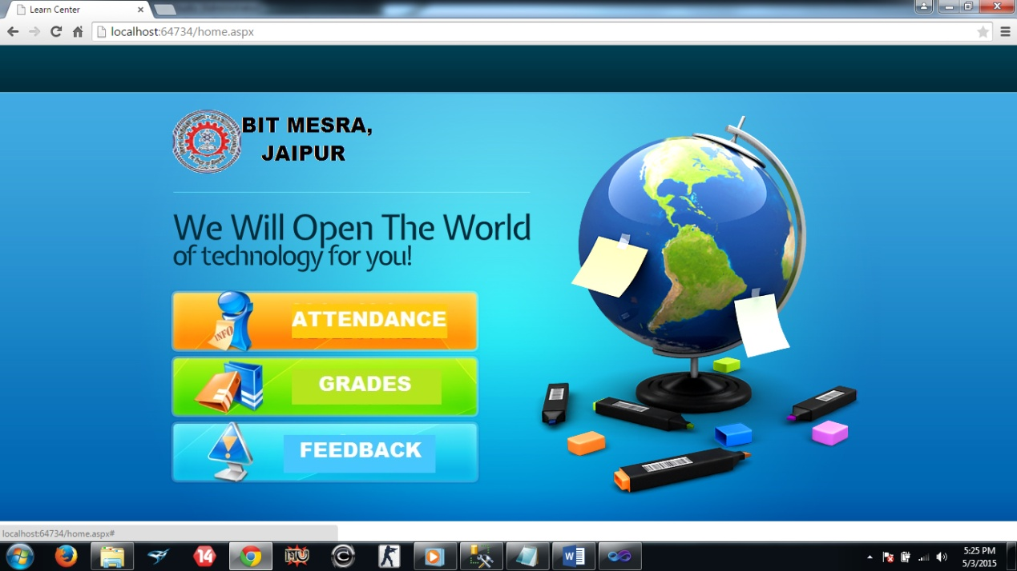

**2.2. Attendance Module**

1. Attendance login

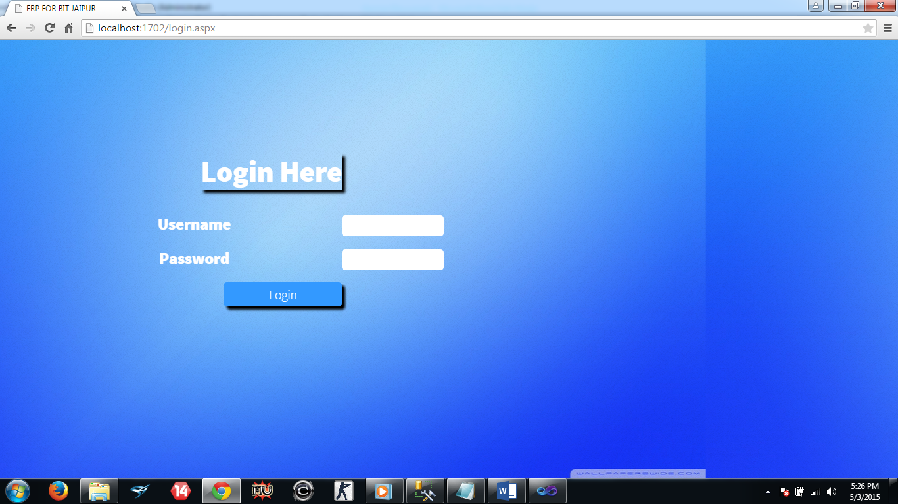

1. Teacher’s subject select

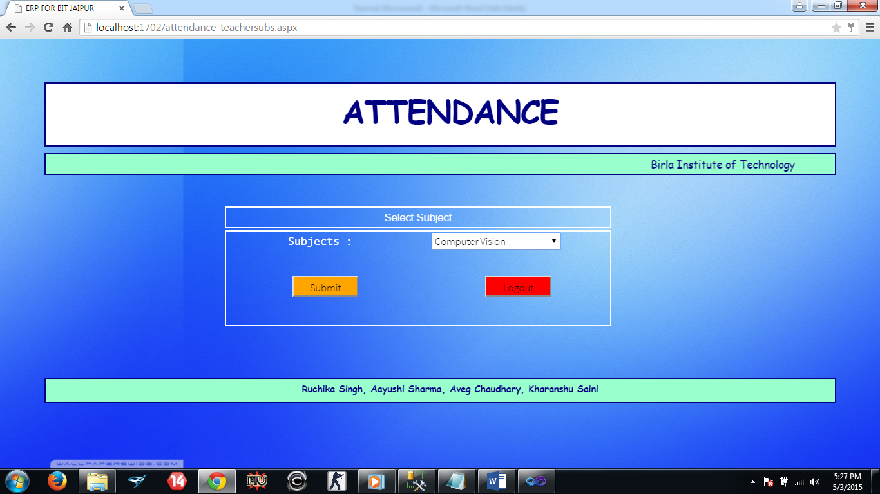

1. Teacher’s Interface

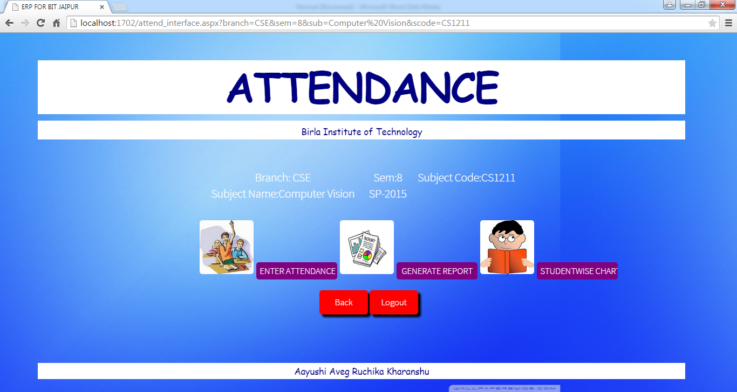

1. Enter attendance

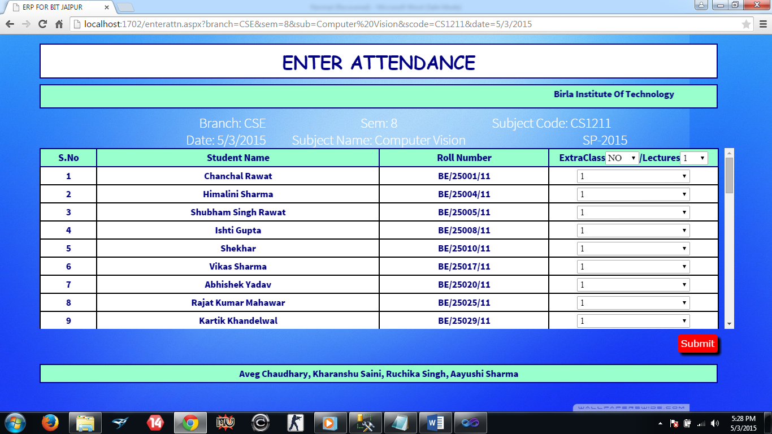

1. Generate report

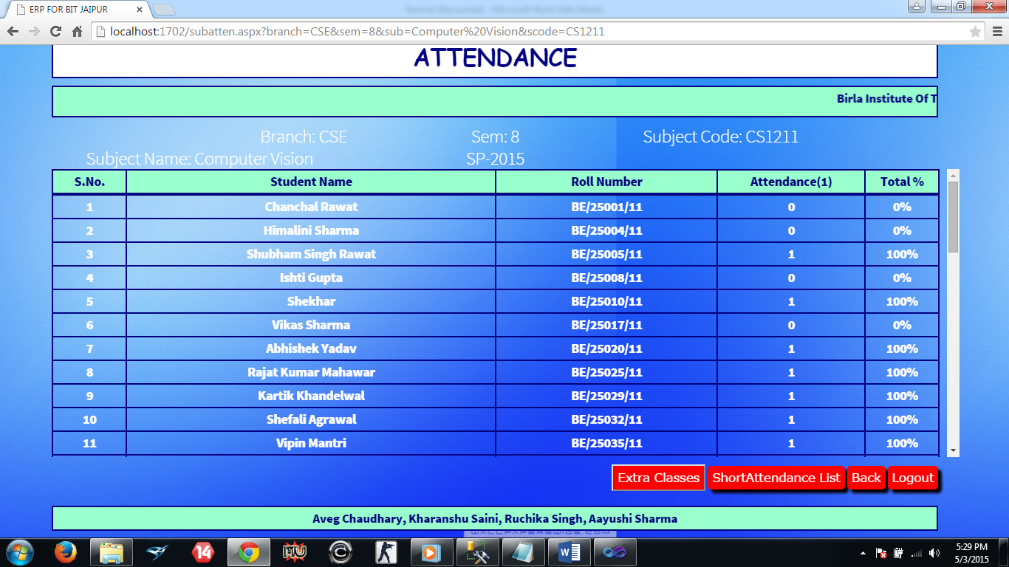

1. Short Attendance

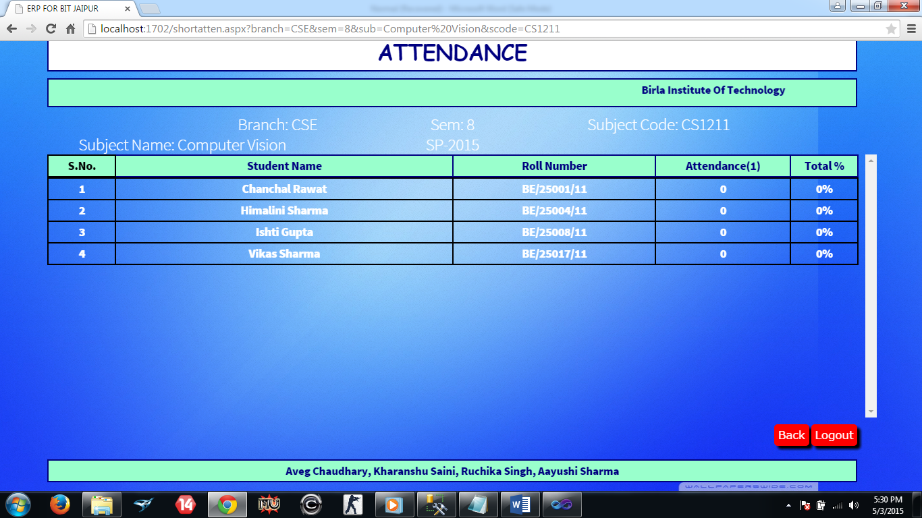

1. Student wise chart

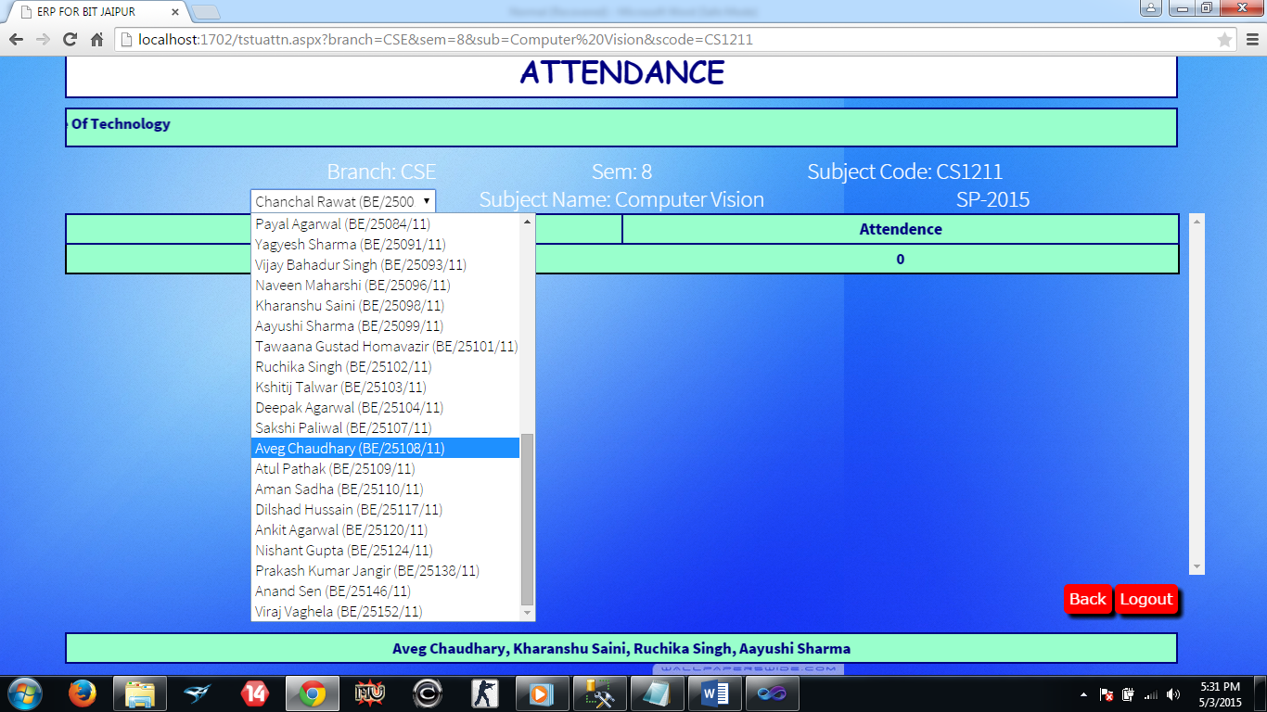

1. Student’s interface

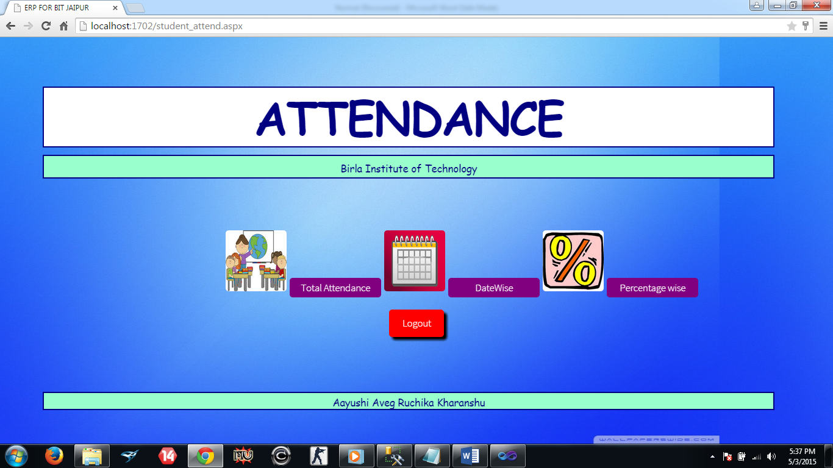

1. Student’s total attendance

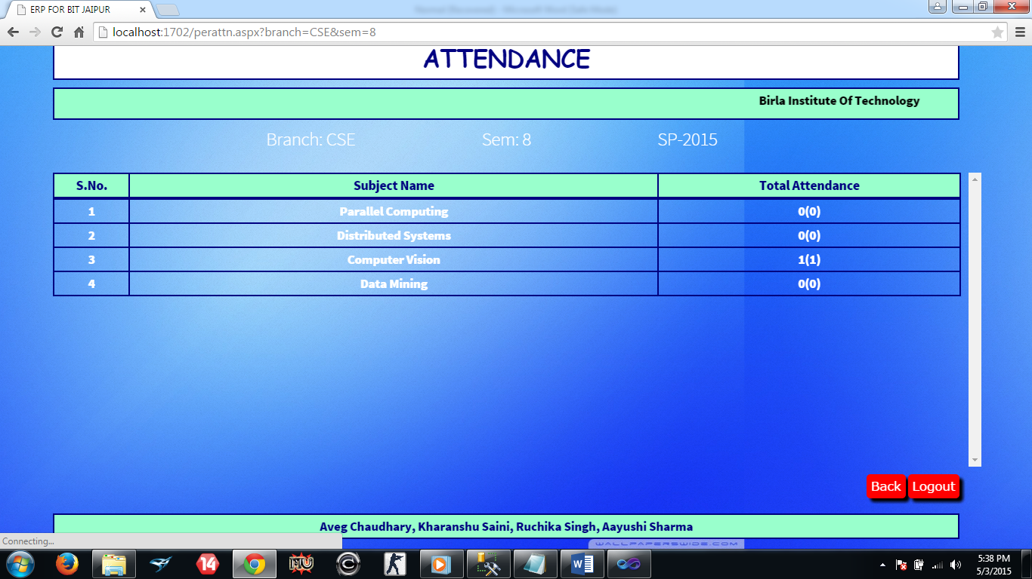

1. Student’s datewise

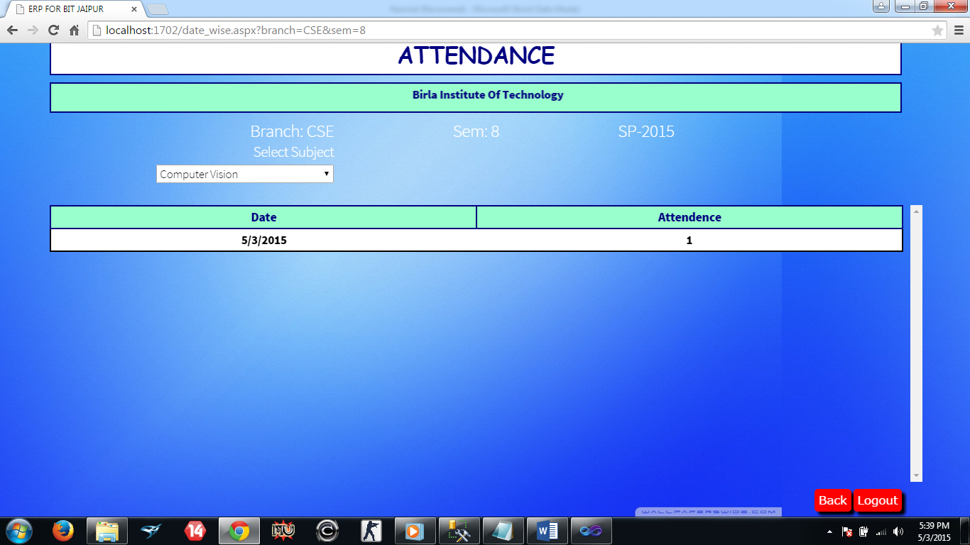

1. Student’s percent-wise

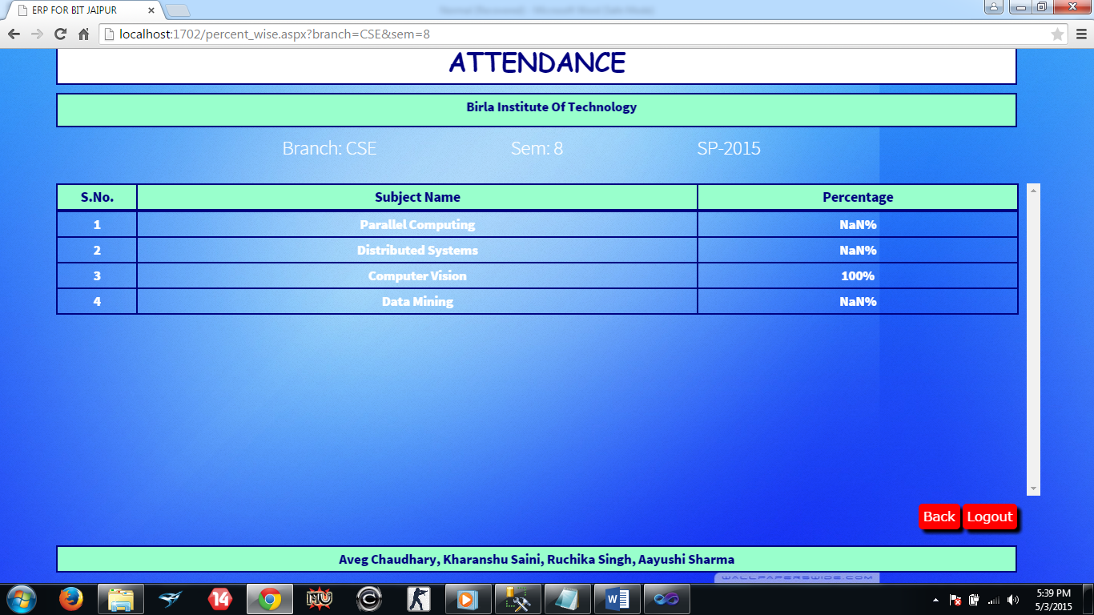

* 1. **Result Module**

1. Faculty subject select

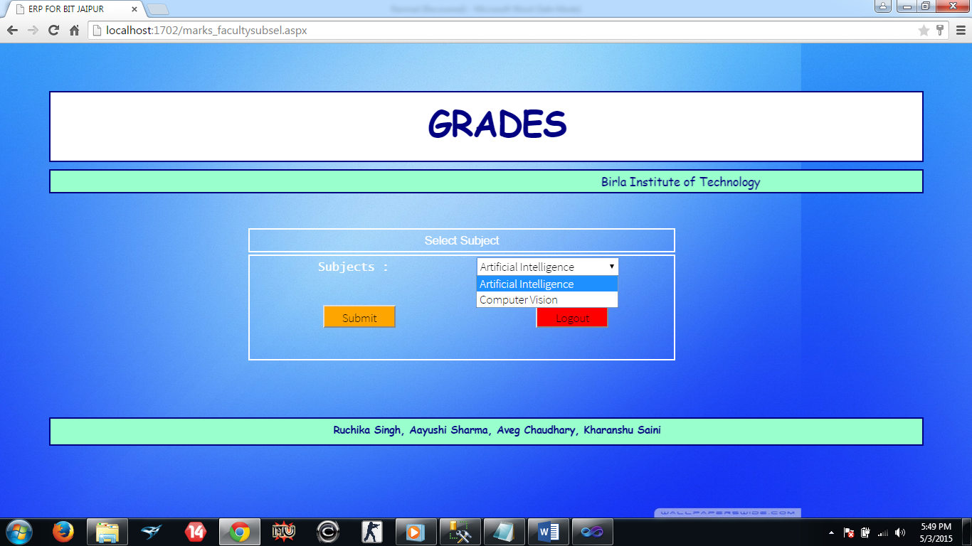

1. Faculty interface

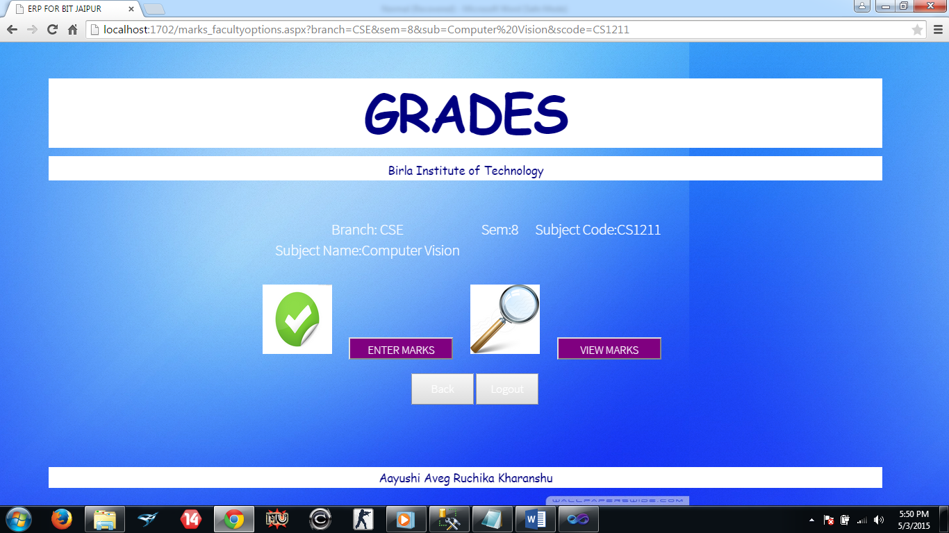

1. Mid/End/Assessment marks

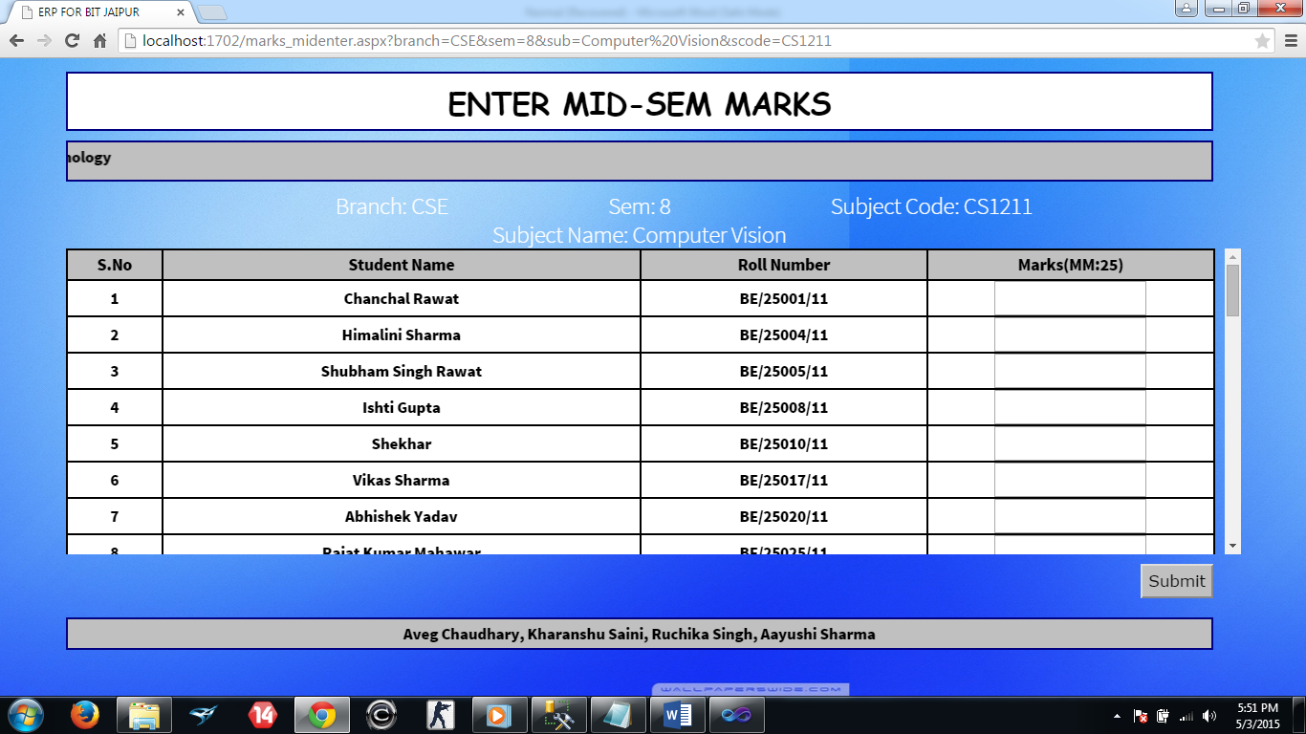

1. View marks

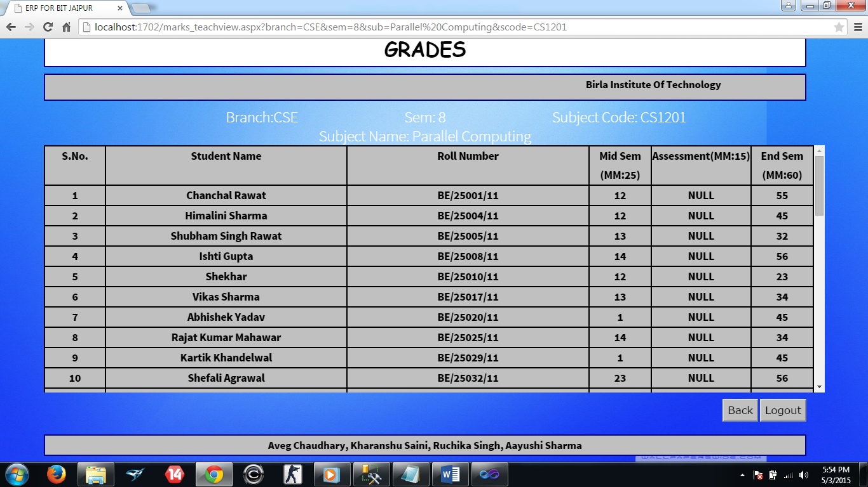

1. Student’s grades interface

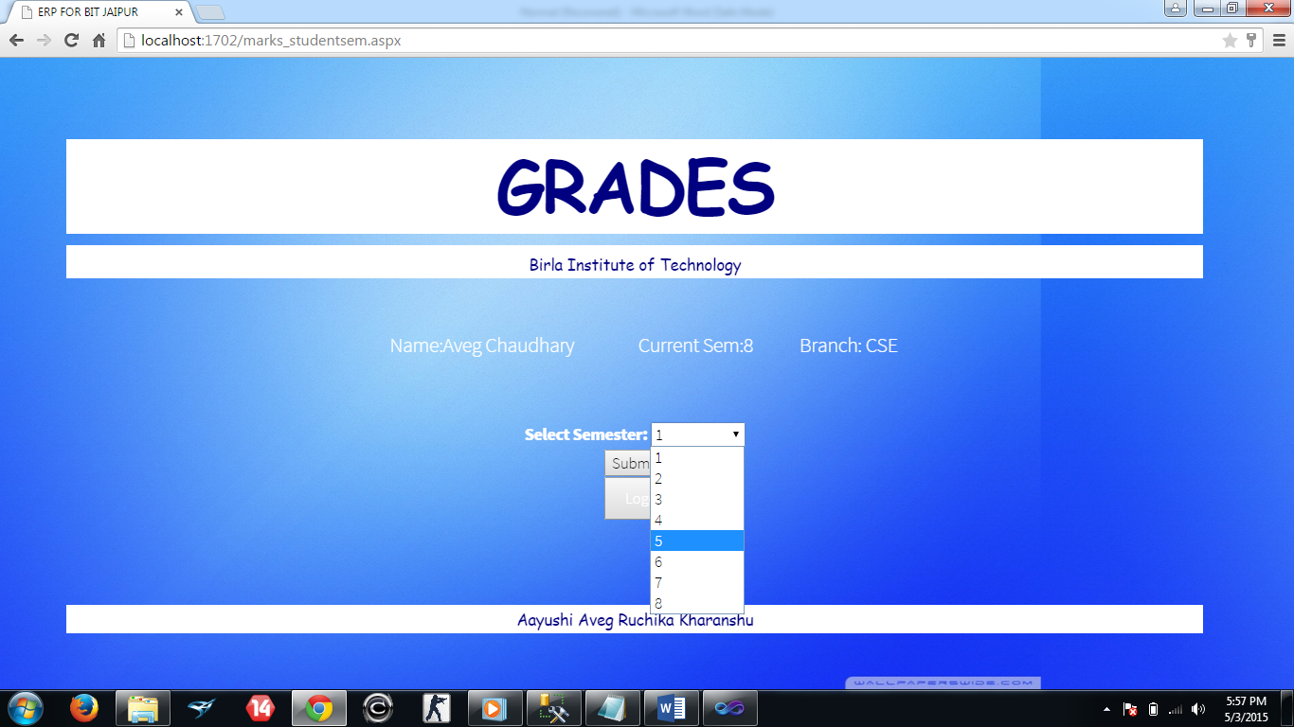

1. Student’s marks in all the subjects

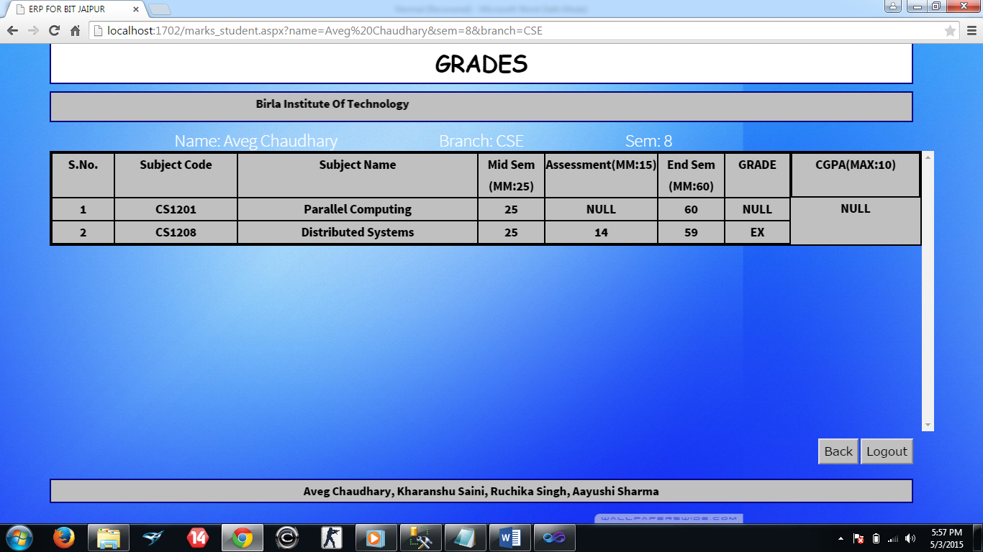

**2.3 Feedback Module**

1. Teacher’s branch, semester select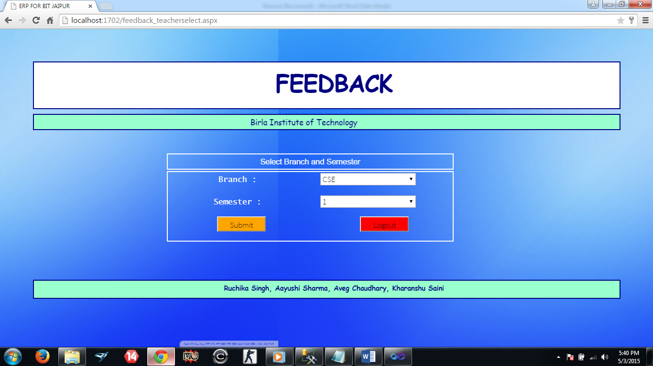

2. Teacher’s feedback interface

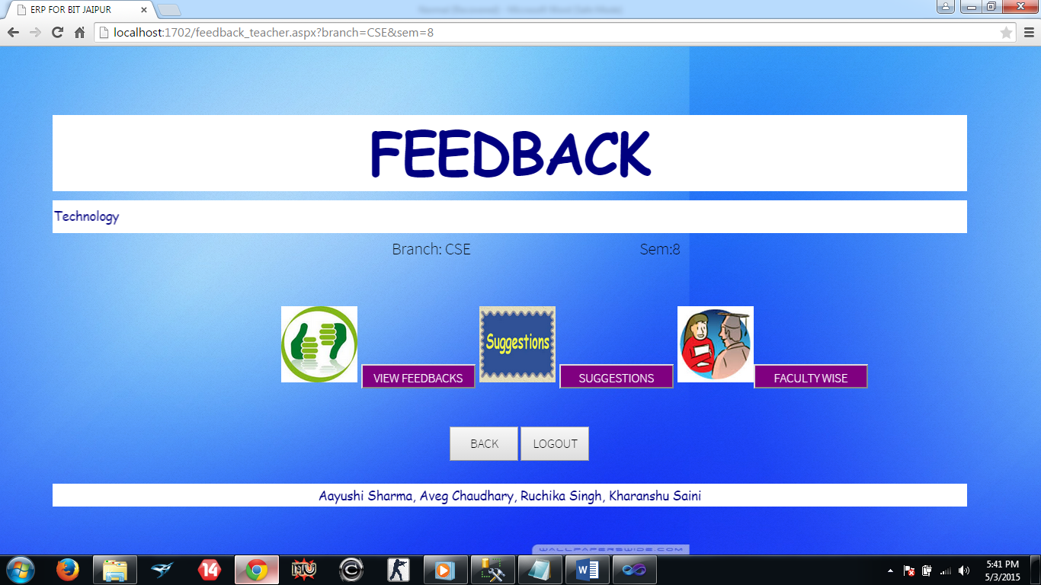

1. Feedback list of all the teacher’s belonging to a particular semester and branch

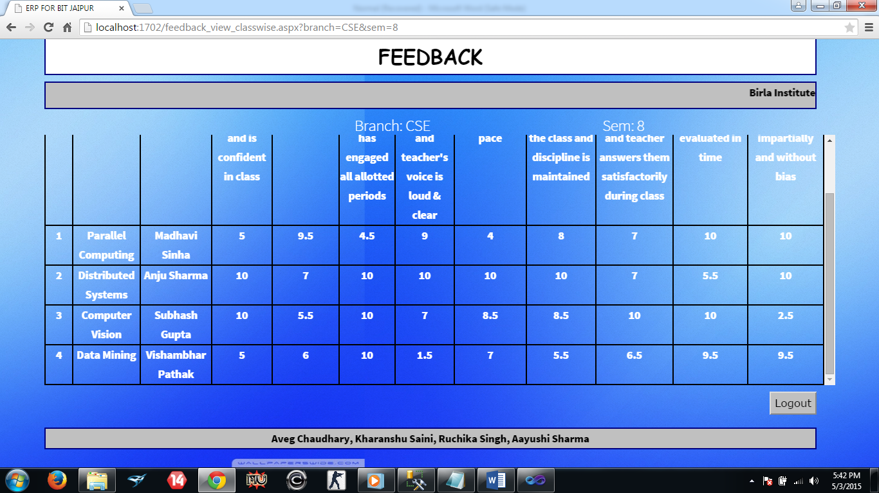

1. Suggestions

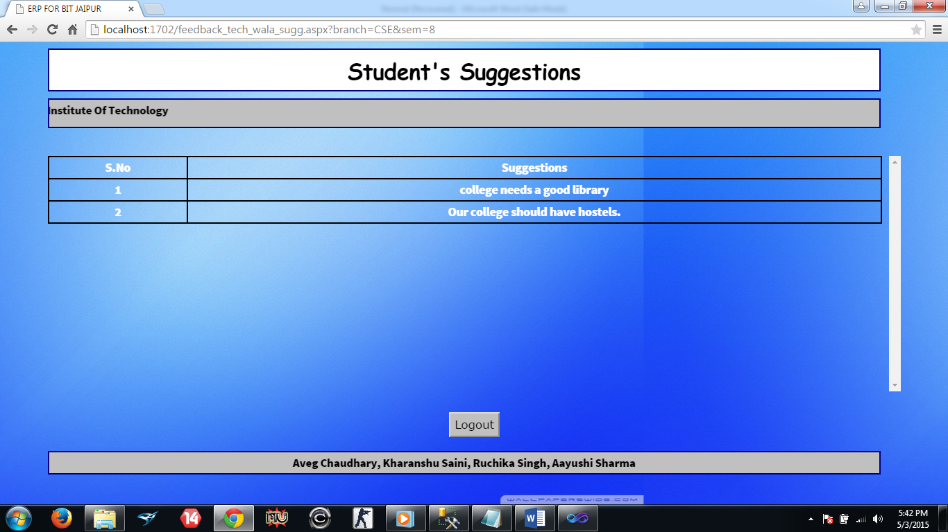

1. Faculty list

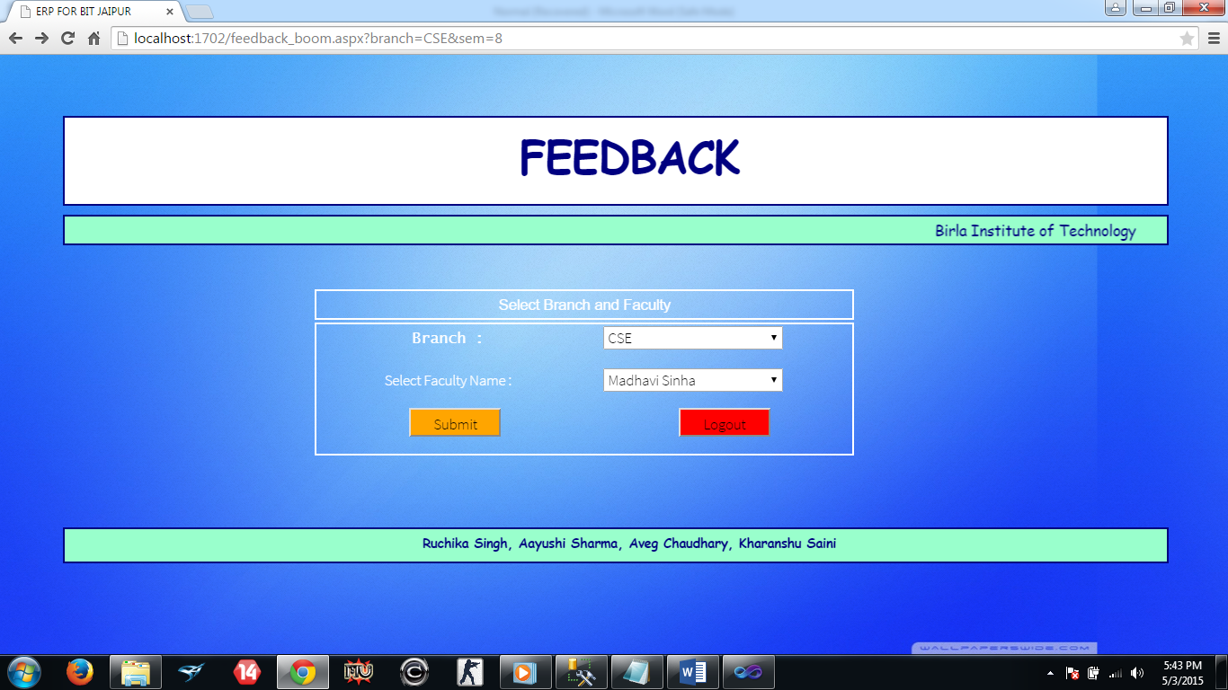

1. Selected teacher’s feedback in all the sub’s

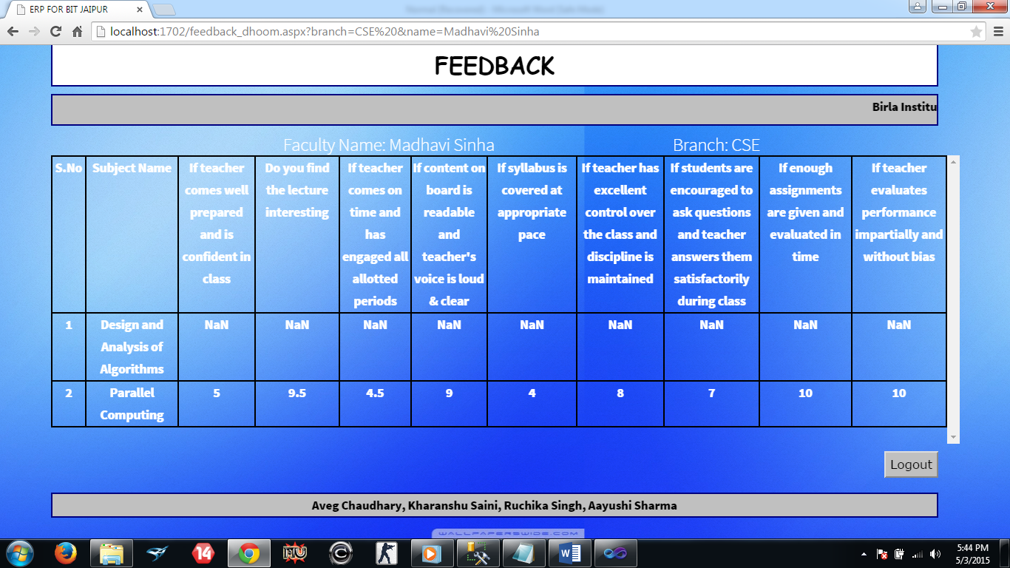

1. Student’s feedback interface

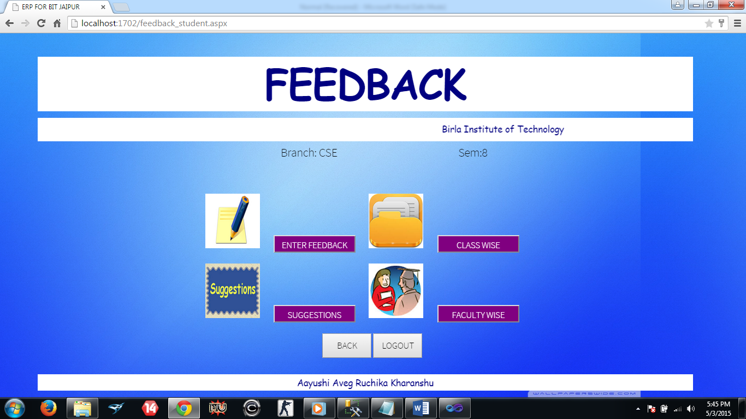

1. Enter Feedback

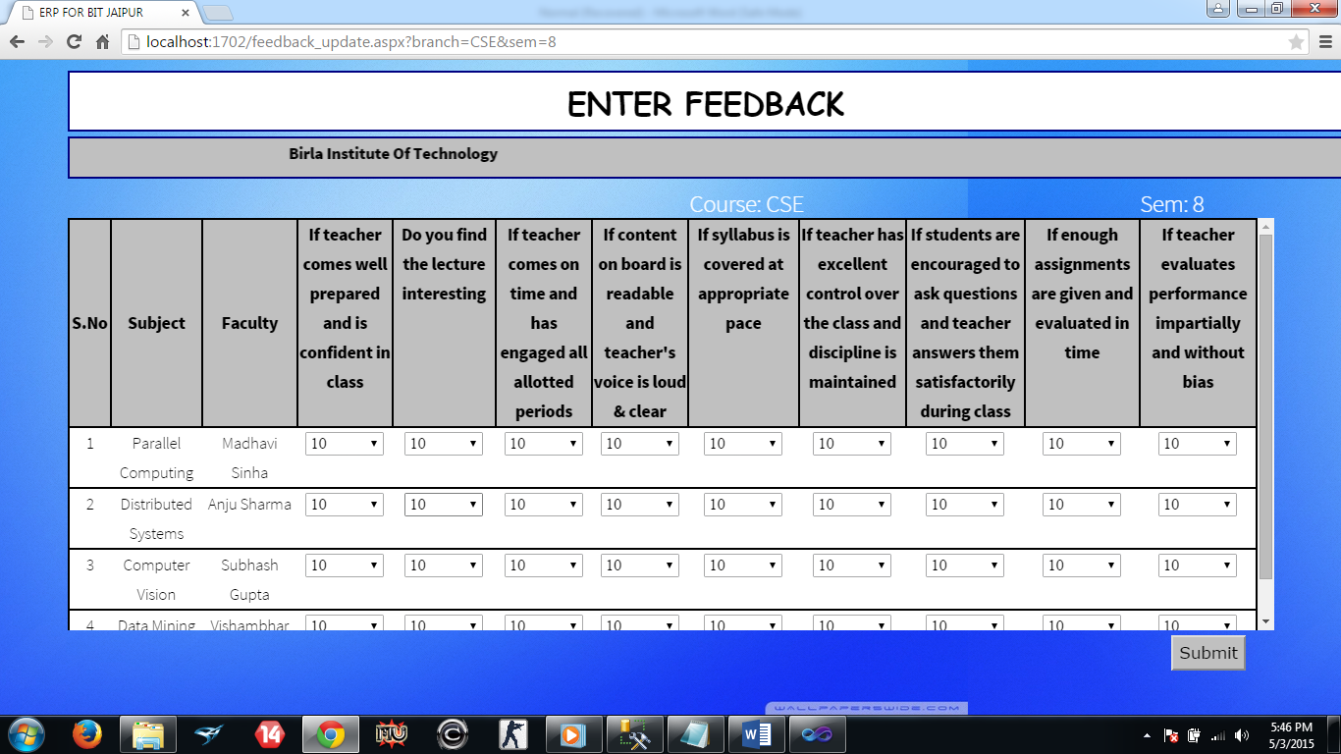

1. Classwise

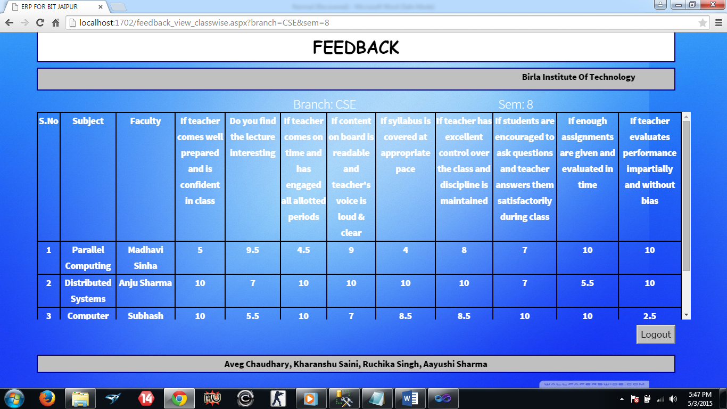

1. Suggestions

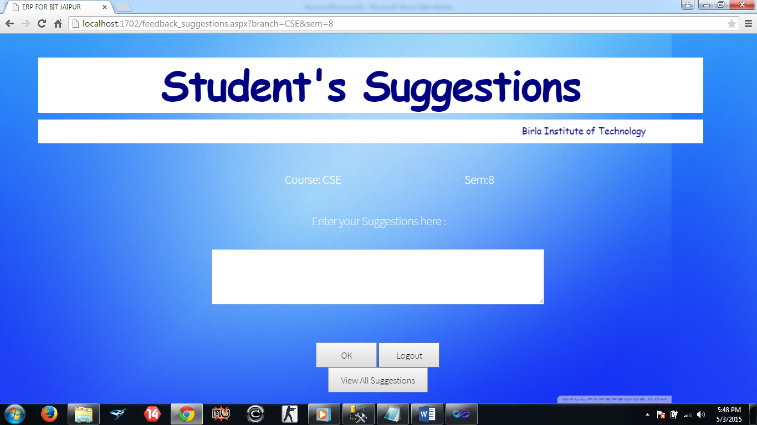

1. View all suggestions

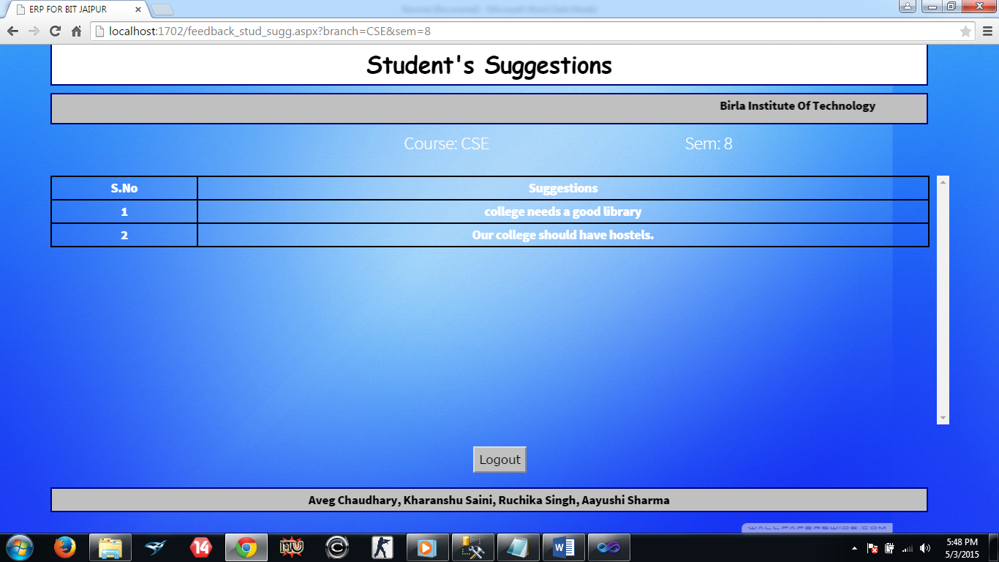

**3.TESTING PROCEDURE**

Once the source code has been developed, testing is required to uncover the errors before it is implemented. In order to perform software testing a series of test cases is designed. Testing means the process of analyzing a software item to detect the difference between existing and acquired conditions and to evaluate the features of the software item. The purpose of testing is to discover errors. Testing is the process of trying to discover every conceivable fault or weakness in a work product. It provides a way to check the functionality of components, subassemblies, assemblies and/or a finished product. It is the process of exercising software with the intent of ensuring that the software system meets its requirements and user expectations and does not fail in an unacceptable manner. There are various types of test. Each test type addresses a specific testing requirement.

## 3.1. Types of Testing

**3.1.1 Unit Testing**

Unit testing involves the design of test cases that validate that the internal program logic is functioning properly, and that program input produces valid outputs. All decision branches and internal code flow should be validated. It is the testing of individual software units of the application .it is done after the completion of an individual unit before integration. This is a structural testing, that relies on knowledge of its construction and is invasive. Unit tests perform basic tests at component level and test a specific business process, application, and/or system configuration. Unit tests ensure that each unique path of a business process performs accurately to the documented specifications and contains clearly defined inputs and expected results.

**3.1.2 Integration Testing**

Integration tests are designed to test integrated software components to determine if they actually run as one program. Testing is event driven and is more concerned with the basic outcome of screens or fields. Integration tests demonstrate that although the components were individually satisfaction, as shown by successfully unit testing, the combination of components is correct and consistent. Integration testing is specifically aimed at exposing the problems that arise from the combination of components.

**3.1.3 System Testing**

System testing ensures that the entire integrated software system meets requirements. It tests a configuration to ensure known and predictable results. An example of system testing is the configuration oriented system integration test. System testing is based on process descriptions and flows, emphasizing pre-driven process links and integration points.

**3.1.4 Functional Testing**

Functional tests provide a systematic demonstration that functions tested are available as specified by the business and technical requirements, system documentation, and user manuals.

Functional testing is centered on the following items:

Valid Input : identified classes of valid input must be accepted.

Invalid Input : identified classes of invalid input must be rejected.

Functions : identified functions must be exercised.

Output : identified classes of application outputs must be exercised.

Systems/Procedures : interfacing systems or procedures must be invoked.

Organization and preparation of functional tests is focused on requirements, key functions, or special test cases. In addition, systematic coverage pertaining to identify business process flows, data fields, predefined processes, and successive processes must be considered for testing. Before functional testing is complete, additional tests are identified and the effective value of current tests is determined.

**3.2. UNIT TESTING**

Unit testing is usually conducted as part of a combined code and unit test phase of the software lifecycle, although it is not uncommon for coding and unit testing to be conducted as two distinct phases.

**Test strategy and approach**

Field testing will be performed manually and functional tests will be written in detail.

**Test objectives**

* All field entries must work properly.
* Pages must be activated from the identified link.
* The entry screen, messages and responses must not be delayed.

**Features to be tested**

* Verify that the entries are of the correct format.
* No duplicate entries should be allowed.
* All links should take the user to the correct page.

# 3.3. INTEGRATION TESTING

Software integration testing is the incremental integration testing of two or more integrated software components on a single platform to produce failures caused by interface defects.

The task of the integration test is to check that components or software applications, ex. components in a software system or one step up software applications at the company level - interact without error.

**Test Results:** All the test cases mentioned above passed successfully. No defects encountered.

**3.4. ACCEPTANCE TESTING**

User Acceptance Testing is a critical phase of any project and requires significant participation by the end user. It also ensures that the system meets the functional requirements.

**Test Results:** All the test cases mentioned above passed successfully. No defects encountered.

## 

## 4. FUTURE SCOPE

College ERP system is successfully implemented and currently the working modules are feedback system, attendance management system and sessional marks management. In the near future the additionally integrated modules will be

* Assignment Management
* Online Notes
* Time Table Generation
* Online Notice Board
* Database Management System

These modules will provide further flexibility and dynamicity to the system and will reduce the work overload on the management. The successful implementation of these modules will automate the functioning of the college system

**5. REFERENCES**

* Seyed Tahaghoghi and Hugh Williams, “Learning MySQL”.
* John Pollock, “JavaScript: A Beginner’s Guide”.
* Ellen Monk and Bret Wagner,“Concepts in Enterprise Resource Planning”.
* Mary Sumner, “Enterprise Resource Planning”.
* Ejaz Ahmed Bhatti, “ERP a Research Study Paper”.